**I do not believe in assigning homework just for the sake of assigning homework.** I will only assign homework that gives your child extra practice or review of what we are learning in class. That being said, I want to stress the **importance of having your child complete their homework** but also doing their homework **on their own**.

**Homework Policy**

**Nightly Reading**

**-** Your child should read for at least **20 minutes each night.**

- Please fill out and sign your child’s reading log every night.

- Reading should be done **EVERY NIGHT (even on weekends)**.

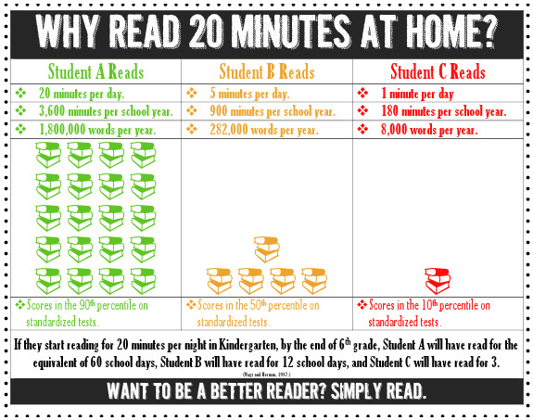

**Math, Writing, and Sight Word Homework**

This homework will start to be sent home the **third week of school**. More information will be sent home at that time. Remember: I only send home concepts that need to be practiced. ☺